**Start your first Azure Virtual Machine (Linux) SOP:**

Description:

In this lab exercise you are going to create a Linux VM (Virtual Machine) using Azure portal. Azure portal provides us various VM images to import according to your requirements. In this exercise you are using Ubuntu 18.04LTS image which is a Linux based OS (Operating System). This SOP outlines the architecture flow, lab steps, troubleshooting and supporting references to help you in achieving the main objective of this exercise.

Open portal.azure.com and log in with your credentials, select **Virtual Machines** on the Home page, click **Add** on the top left, select the **Subscription** and **Resource Group**, provide the required **VM name** and **Region**, set the **availability options**, and choose the **Image** (Ubuntu Server 24.04-LTS).

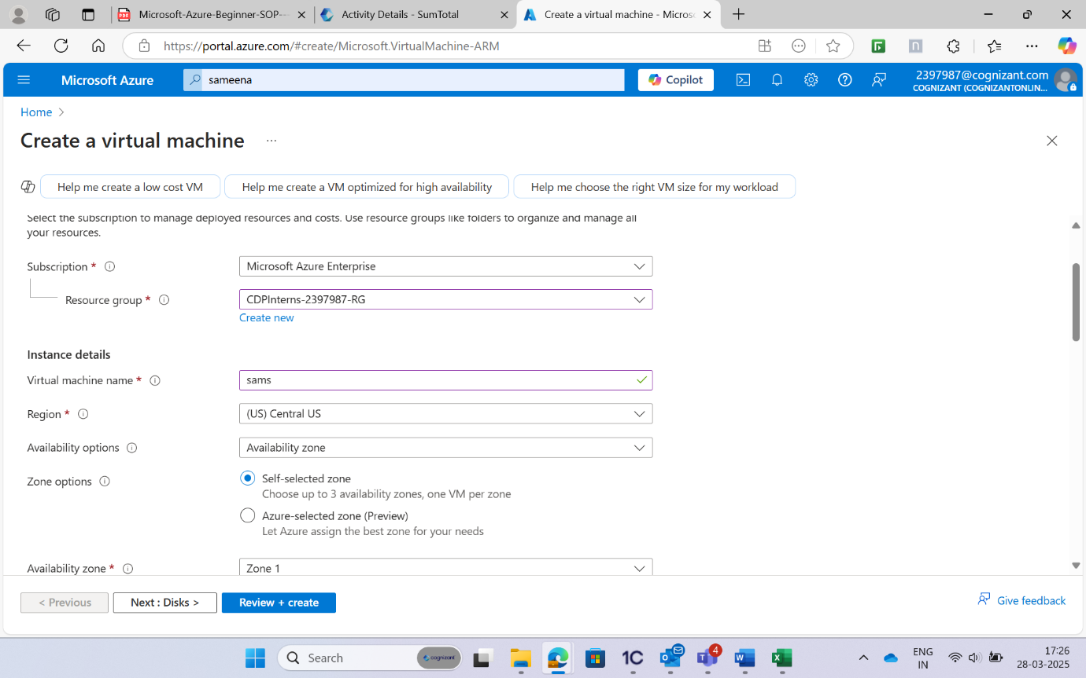

Select the required size and then select the SSH public key or Password as required.

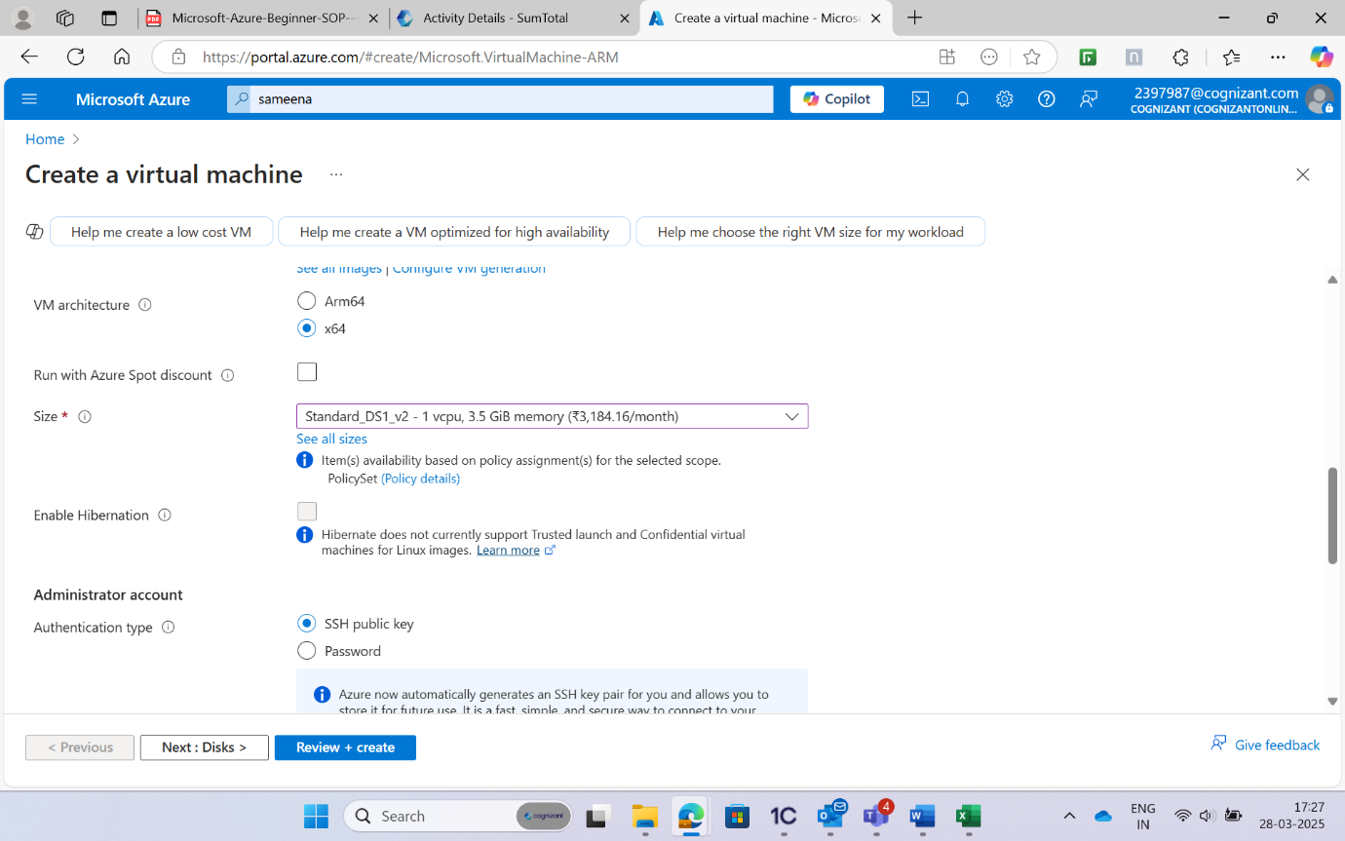

Fill in the required details, set the inbound rules, proceed to **Disks** and select the appropriate disk type, choose the encryption type, and create or attach a new disk or attach to an existing disk as needed.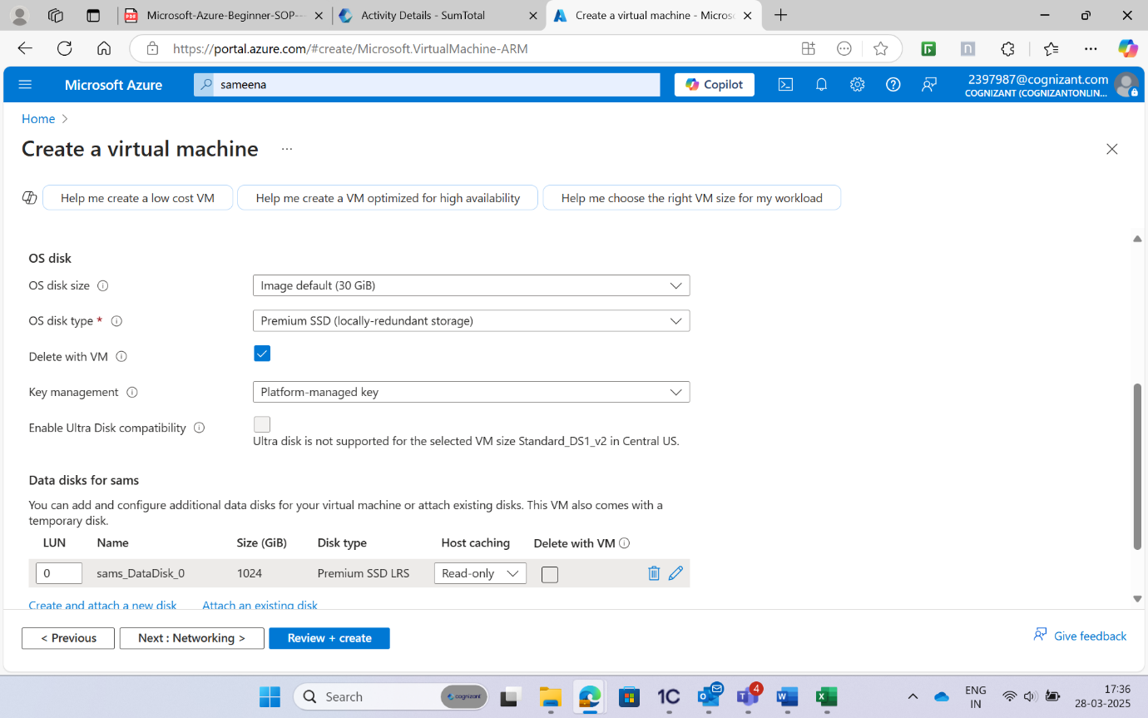

Proceed to Networking and check the virtual network, subnet and public IP.

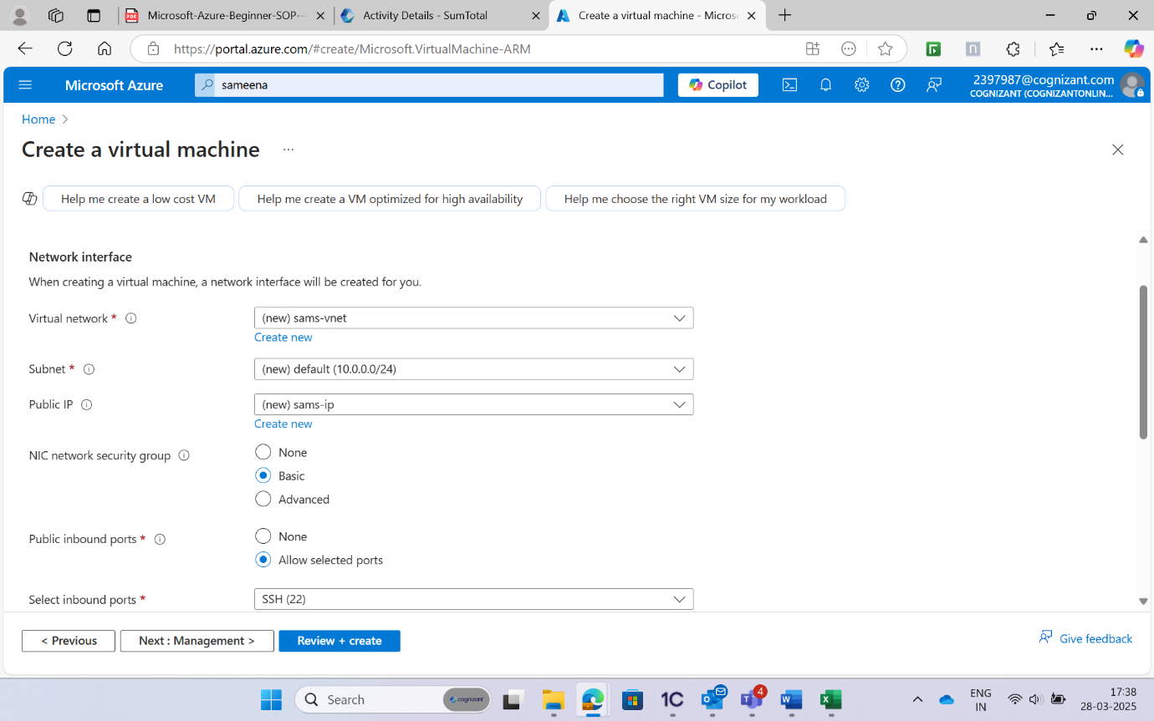

Check the inbound ports and add any if required, proceed to **Monitoring** to customize the tools as needed, and then click **Review + Create**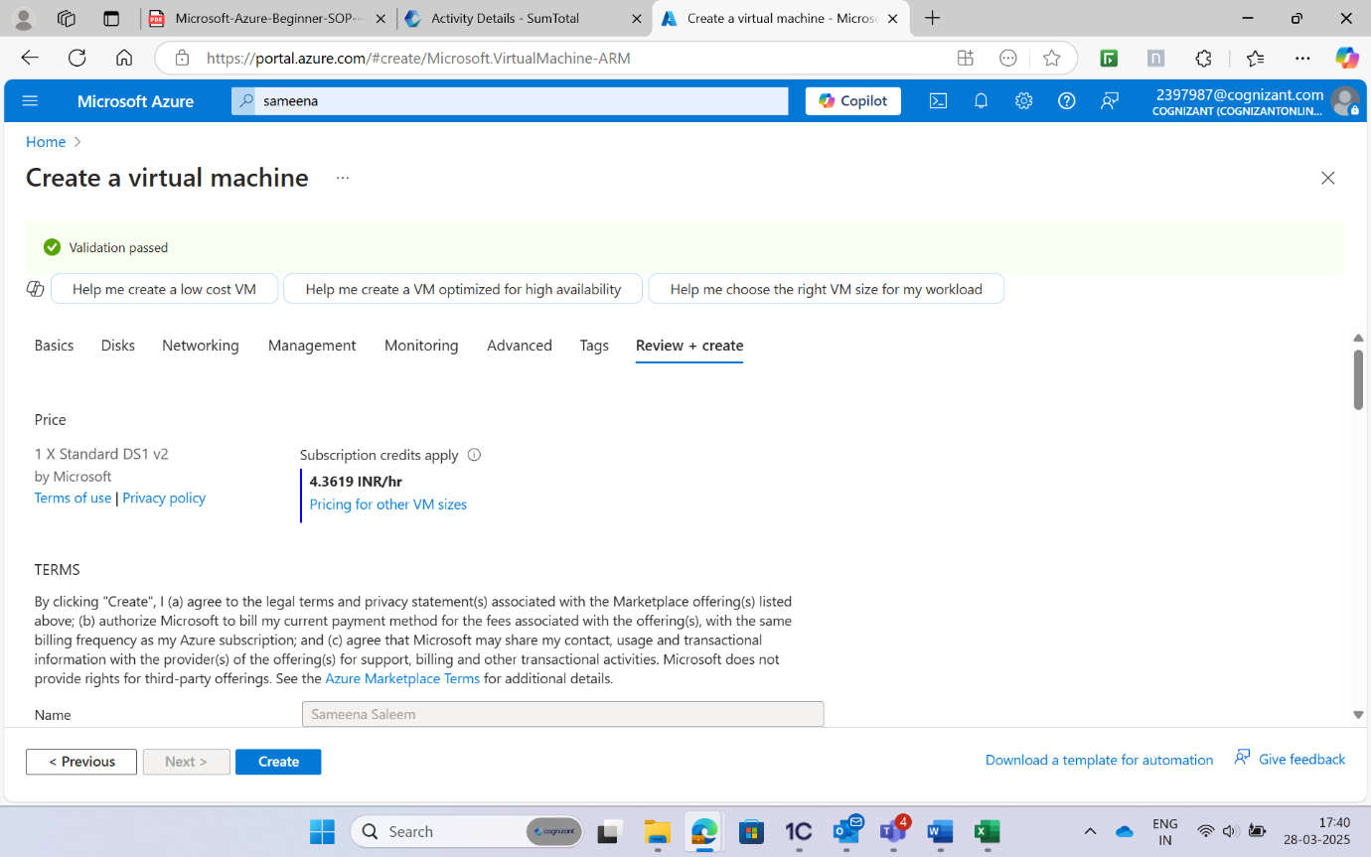

Now click on Download private key and create resource: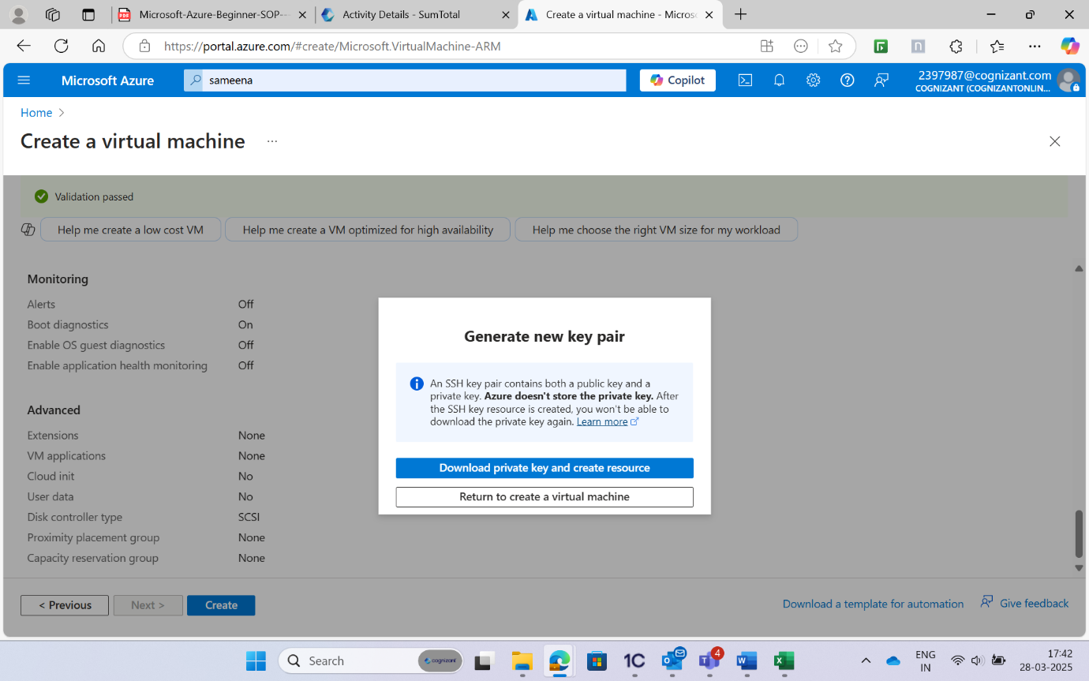

Once the validation process is checked, proceed with create and your VM is deployed in a few minutes.

Once the connection is succeeded, create a resource group by using the following command or use an existing resource group:

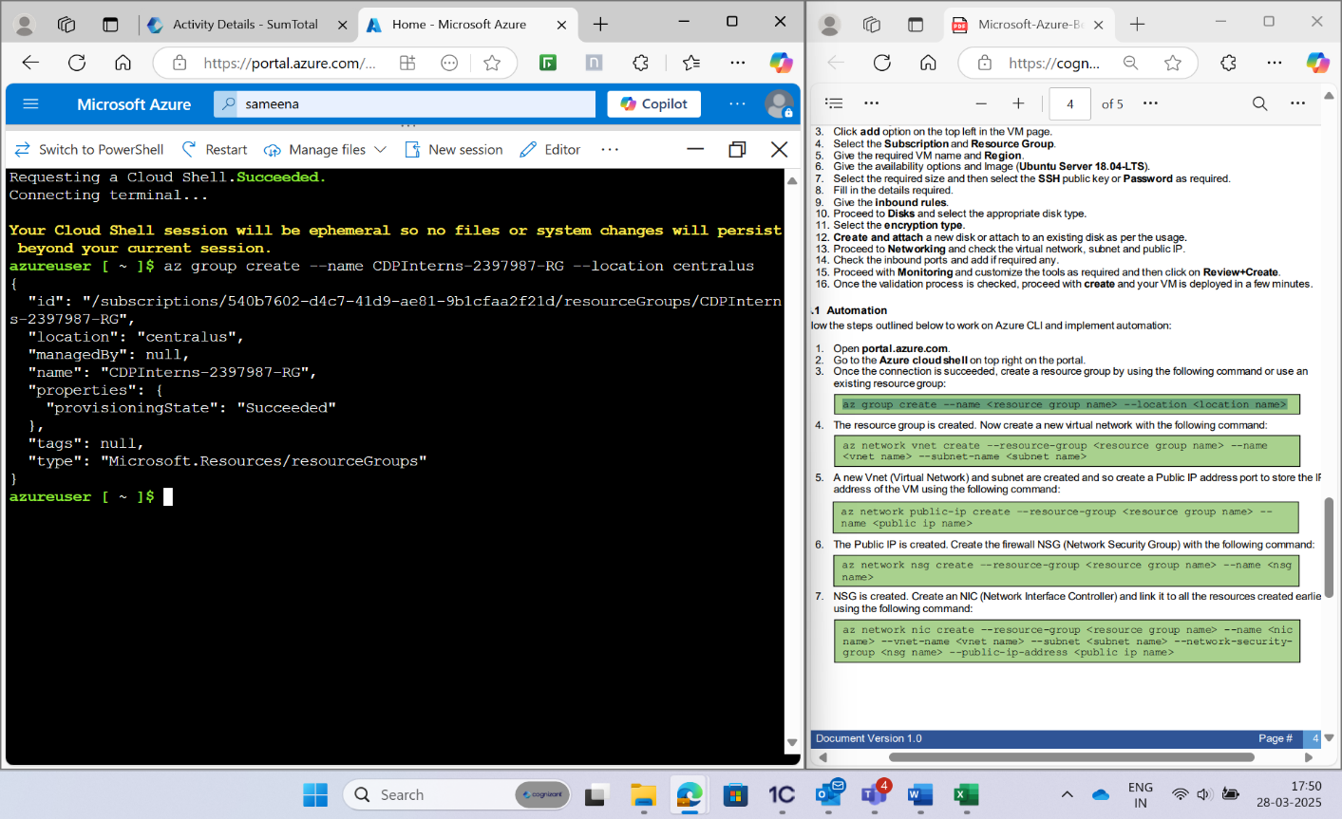

The resource group is created. Now create a new virtual network with the following command:

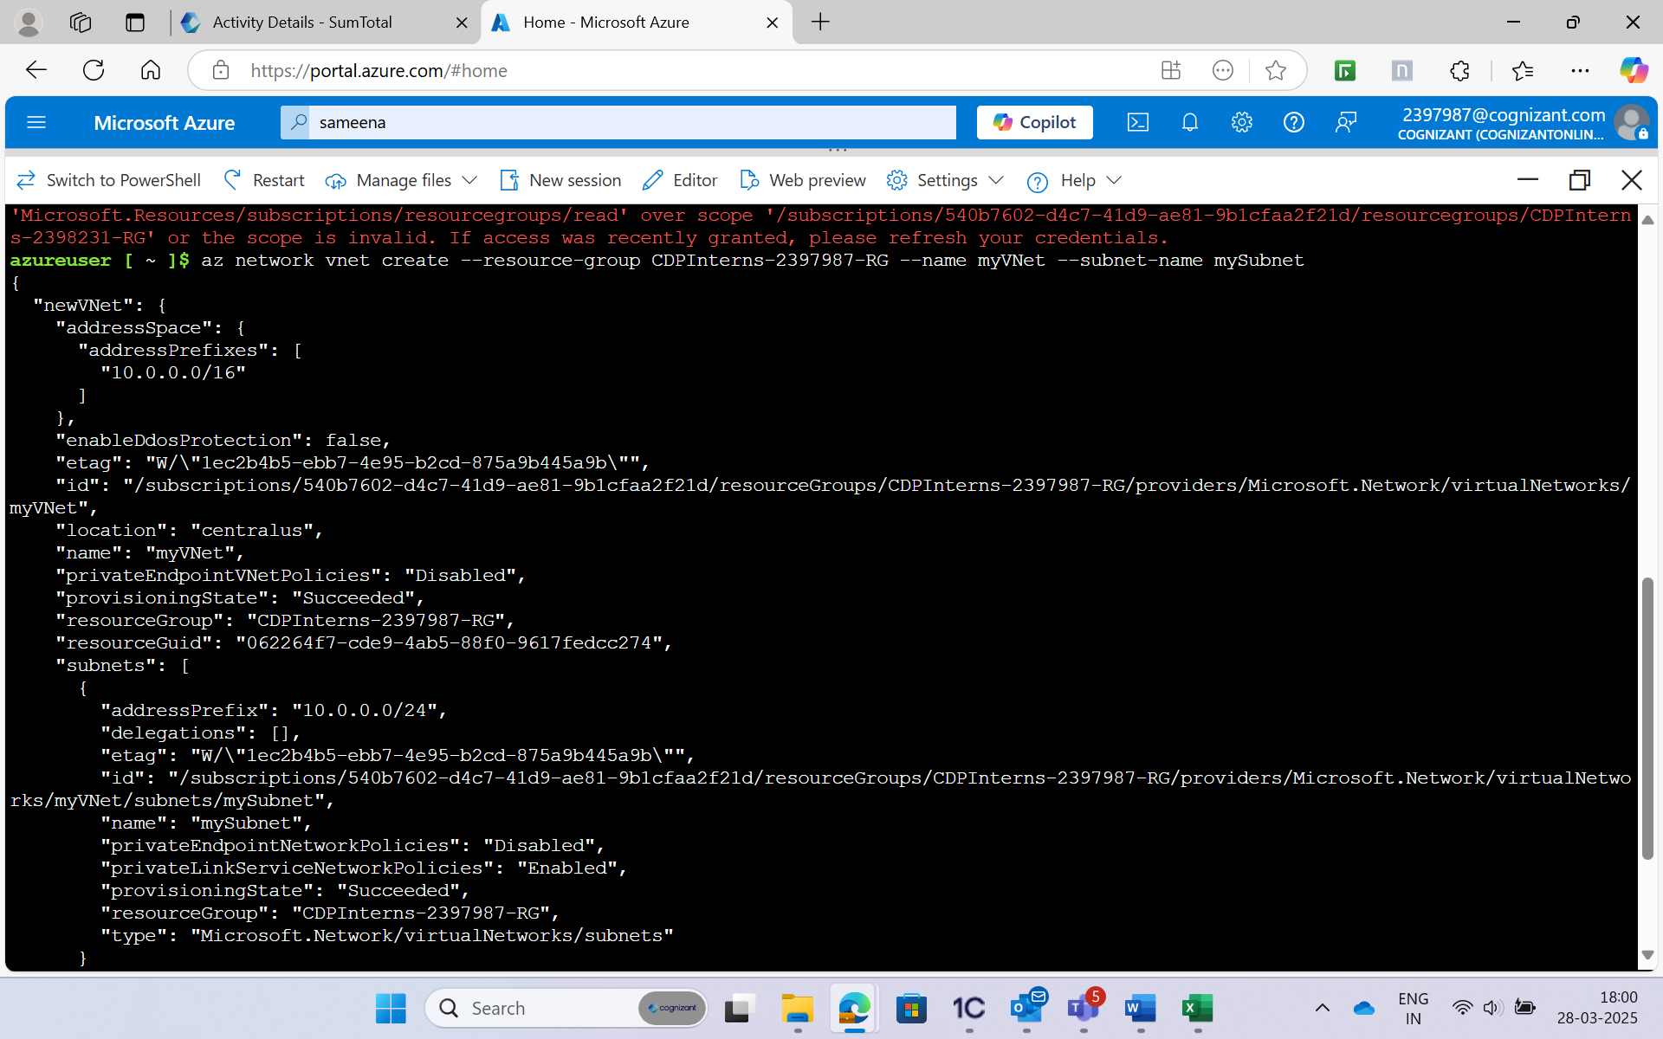

A new Vnet (Virtual Network) and subnet are created and so create a Public IP address port to store the IP address of the VM using the following command:

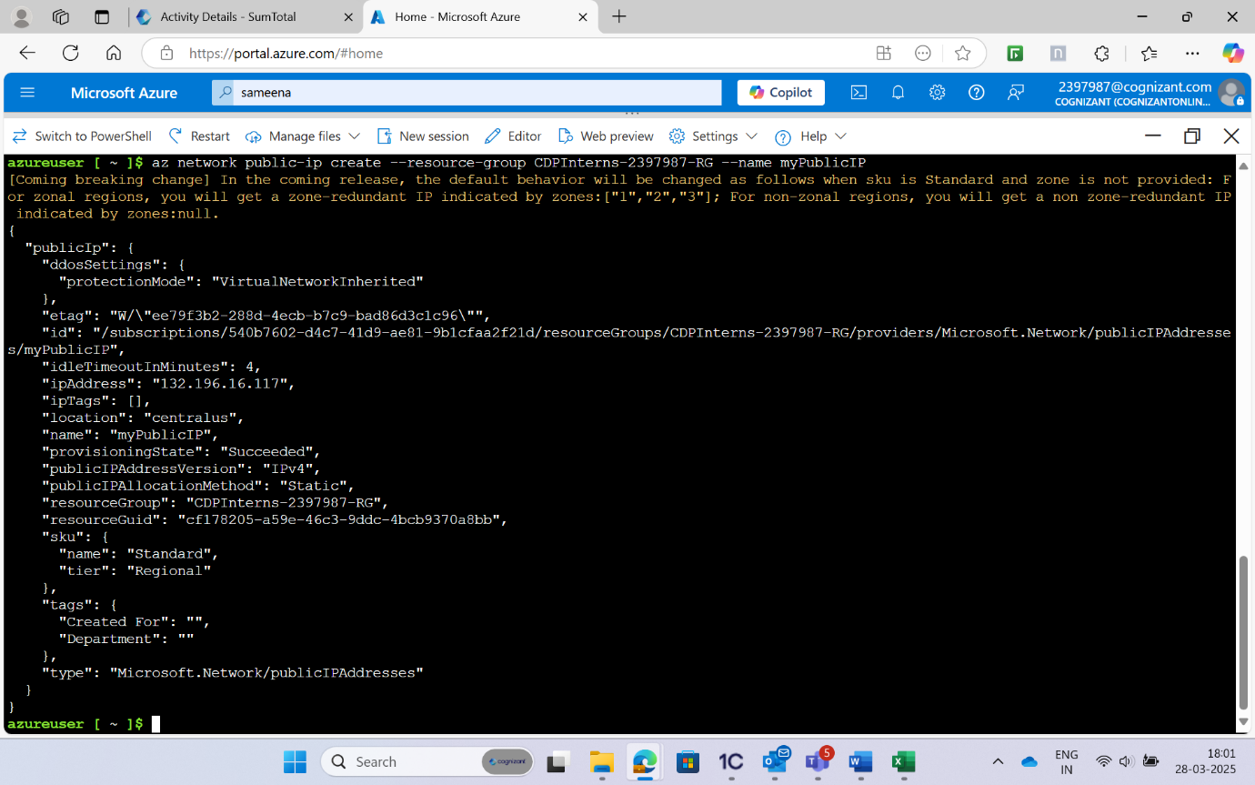

The Public IP is created. Create the firewall NSG (Network Security Group) with the following command:

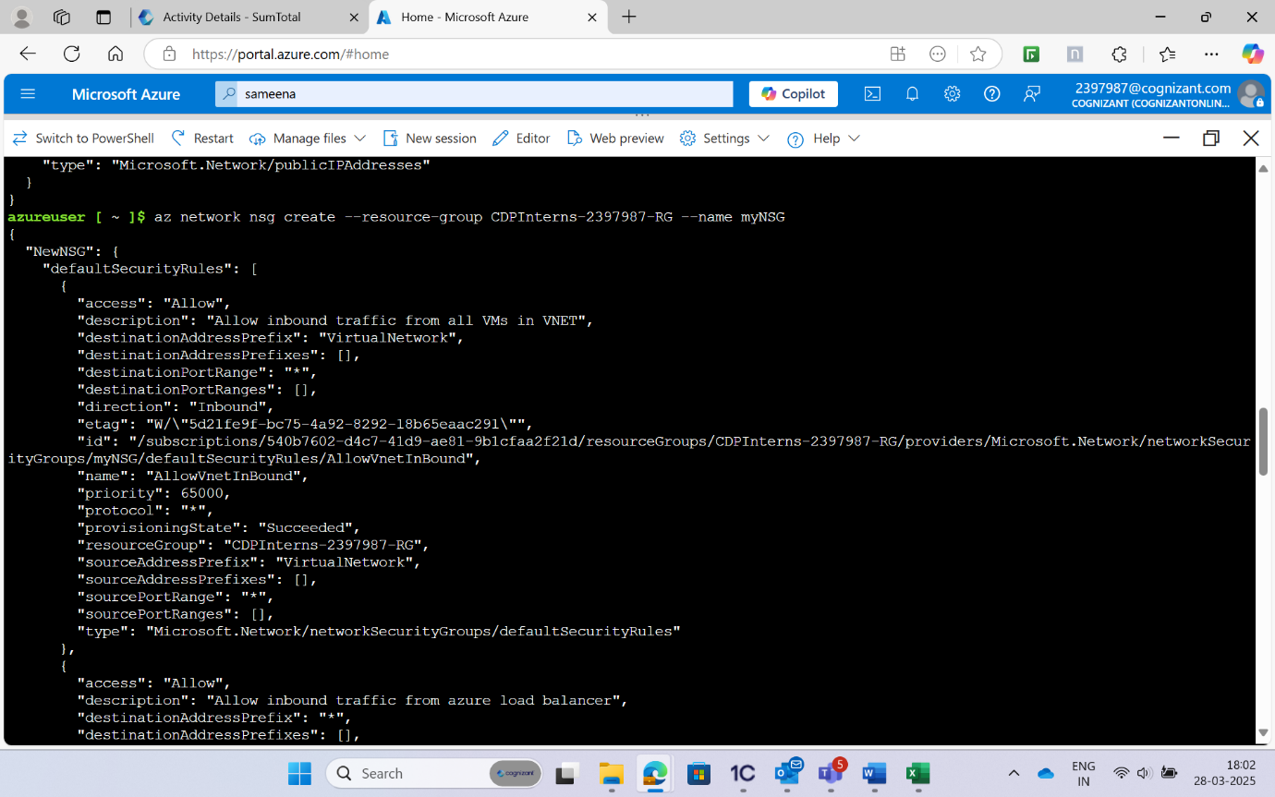

NSG is created. Create an NIC (Network Interface Controller) and link it to all the resources created earlier using the following command:

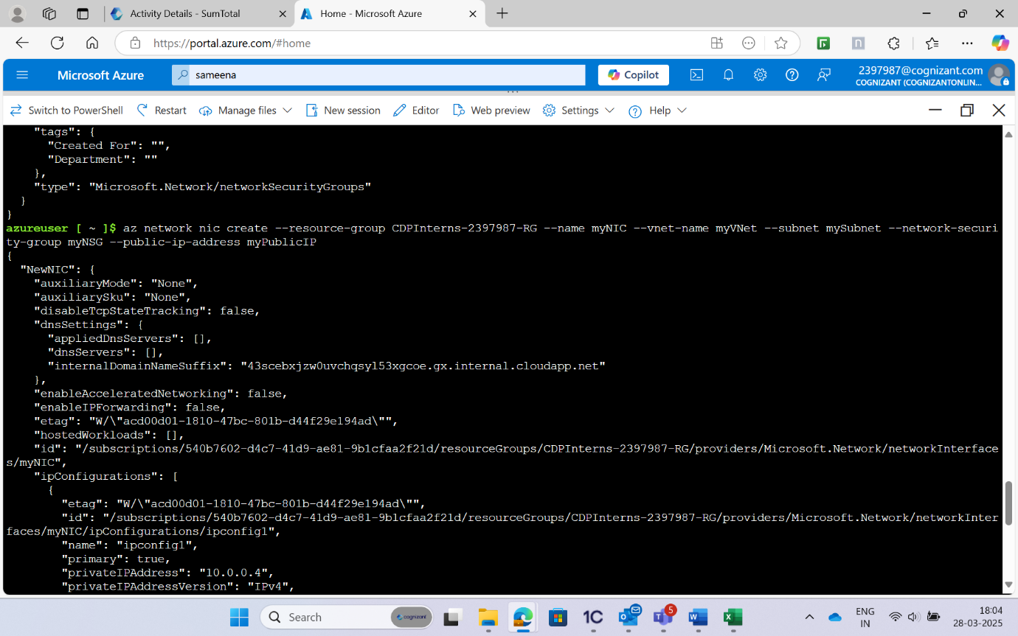

Proceed to create the VM with the following command as you created all the resources required:

